1. Createa tablenameSTUDENTwithfollowingstructure.

|  |  |  |  |
| --- | --- | --- | --- |
| # | Column | Description | DataType |
| Name |
| 1 | RegNo | Registration | NUMBER(3) |
| Number |
| 2 | Name | StudentName | VARCHAR(15) |
| 3 | Gender | Genderofthe | CHAR(1) |
| student |
| 4 | DOB | DateofBirth | DATE |
| 5 | MobileNo | MobileNumber | NUMBER(10) |
| 6 | City | Locationofstay | VARCHAR(15) |

1. Createa tablenameFACULTYwithfollowingstructure.

|  |  |  |  |
| --- | --- | --- | --- |
| # | Column | Description | DataType |
| Name |
| 1 | FacNo | FacultyIdentifier | VARCHAR(4) |
| 2 | FacName | FacultyName | VARCHAR(15) |
| 3 | Gender | Genderoffaculty | CHAR(1) |
| 4 | DOB | DateofBirth | DATE |
| 5 | DOJ | DateofJoin | DATE |
| 6 | MobileNo | MobileNumber | NUMBER(10) |

1. Createa tablenameDEPARTMENTwithfollowingstructure.

|  |  |  |  |
| --- | --- | --- | --- |
| # | Column | Description | DataType |
| Name |
| 1 | DeptNo | DepartmentIdentifier | VARCHAR(4) |
| 2 | DeptName | DepartmentName | VARCHAR(15) |
| 3 | DeptHead | DepartmentHead | VARCHAR(4) |

1. Createa tablenameCOURSEwithfollowingstructure.

|  |  |  |  |
| --- | --- | --- | --- |
| # | Column | Description | DataType |
| Name |
| 1 | CourseNo | CourseIdentifier | VARCHAR(3) |
| 2 | CourseDesc | Course | VARCHAR(14) |
| Description |
| 3 | CourseType | CourseType | CHAR(1) |
| 4 | SemNo | SemesterNumber | CHAR(1) |
| 5 | HallNo | HallNumber | VARCHAR(4) |
| 6 | FacNo | FacultyIdentifier | VARCHAR(4) |

1. ModifythetableFACULTY byaddingacolumnnameDeptNoofdatatypeVARCHAR(4)

##### OUTPUTS:

1)

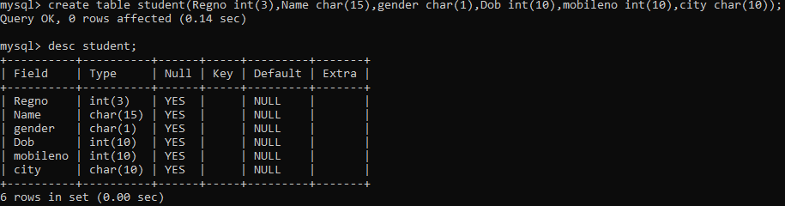

2)

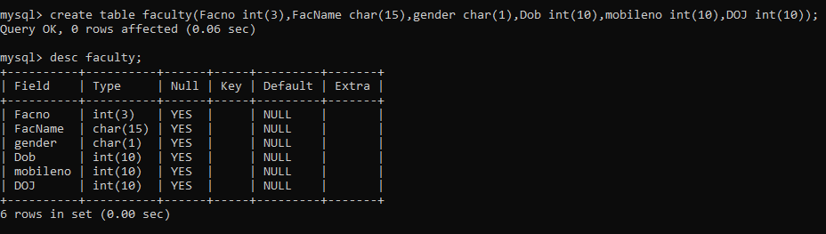

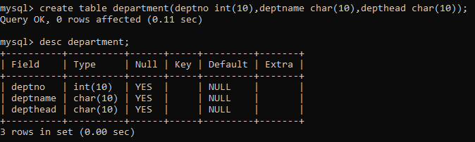3)

4)

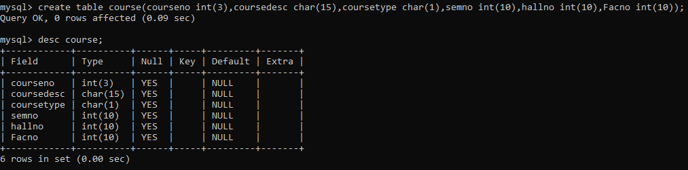

5)

